**MAT1011 – Calculus for Engineers (MATLAB), Fall Semester 2020-2021**

**Digital Assignment SL. 3, Experiment – 2A: Applications of Integration: Finding Area, volume of solid of revolution**

**By: Jonathan Rufus Samuel (20BCT0332) Date: 28.11.2020**

__________________________________________________________________________________

**Q1) Write a program to find the area of the region bounded by the curves y^2 = x, y = x – 2 in the first quadrant and visualize it.**

A: Code is as follows:

%find the area of the region bounded by the curves y^2 = x, y = x – 2 in

% the first quadrant and visualize it.

clear

clc

syms y

f(y) = y^2;

g(y) = y+2;

I=[0,2]; % Interval of Integration

a=I(1);

b=I(2);

A = int(f(y)-g(y),a,b); % Finding the area by integration

disp('Area bounded by the curves f(x) and g(x) is:' );

disp(abs(A));

fplot(f(y),[a,b]);grid on;hold on; %Plotting the upper curve

fplot(g(y),[0,b]);hold on; %Plotting the lower curve

xlabel('x-axis');

ylabel('y-axis');

legend('x=f(y)','x=g(y)');

Output (via Command Window):

Area bounded by the curves f(x) and g(x) is:  
10/3

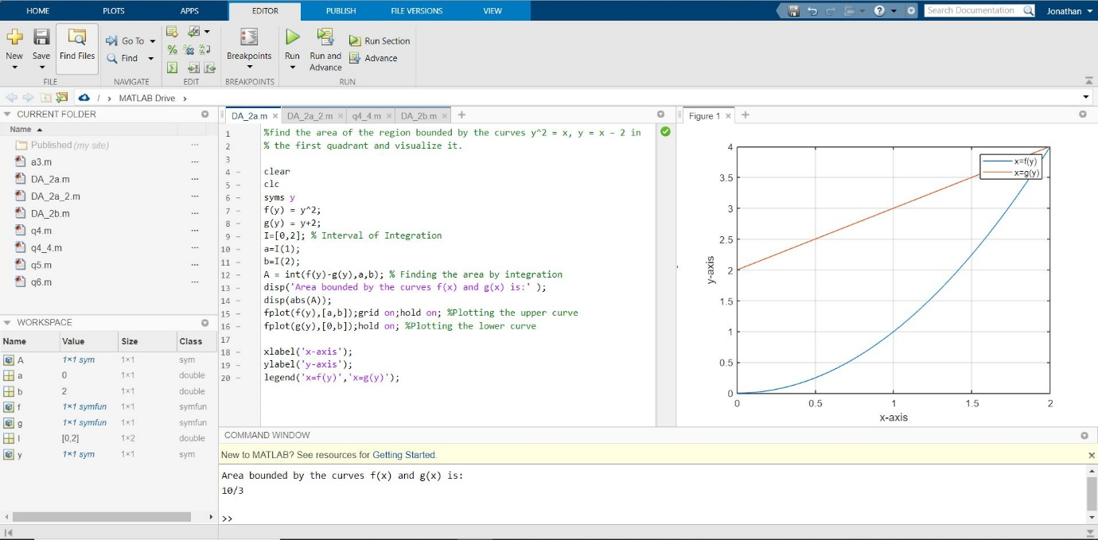

**Q2) Find the volume of the solid generated by revolving about the x-axis the region bounded by the curve y = 4/((x^2)+4), the x-axis, and the lines x = 0, x = 2.**

A: Code is as follows:

%Find the volume of the solid generated by revolving

% about the x-axis the region bounded by the curve y = 4/((x^2)+4),

% the x-axis, and the lines x = 0, x = 2.

clear all

clc

syms x

f(x) = 4/((x^2)+4);

yr = 0; % Axis of revolution y = 0

I = [0,2]; % Interval of integration between x=0 and x=2

a = I(1); b=I(2);

vol = pi*int((f(x)-yr)^2,a,b);

disp('Volume of solid of revolution is: ');

disp(vol);

% Visualization of solid of revolution

fx = matlabFunction(f);

xv = linspace(a,b,101); % Creates 101 points from a to b

[X,Y,Z] = cylinder(fx(xv)-yr);

Z = a+Z.*(b-a);

surf(Z,Y+yr,X) % Plotting the solid of revolution about y = yr (X-AXIS)

hold on;

plot([a b],[yr yr],'-r','LineWidth',2); % Plotting the line y=yr

view(22,11); % 3-D graph viewpoint specification

xlabel('X-axis');ylabel('Y-axis');zlabel('Z-axis');

Output (via Command Window):

Volume of solid of revolution is:   
pi*(pi/4 + 1/2)



